Fun and Learning for Parents and Children: An Activities Handbook
Children are learning all the time. Parents will find this booklet helpful with great activities to share with their children. The booklet contains fun activities for parents and children to do together at home, away from home, indoors, and outdoors.

Introduction
Welcome to Fun and Learning for Parents and Children! This booklet contains fun activities for you and your children. It is a collection of things to do that can be part of your family's everyday life in each room of your home, outdoors, and away from home. Just because an activity is described in one room of your home does not mean that it could not be done somewhere else. Many of the ideas in this booklet might be routines you are doing already. If there are some new ideas, we hope you will use them. The more you enjoy playing with your children, the more they may be able to learn. Your children's abilities to learn many skills in the early years will depend on their stages of development and their individual interests. In addition, their learning will depend on the opportunities and support that the family offers them at home and in their surroundings. Here are a few helpful hints to assist you in planning and doing the activities with your children.
- Establish some rules with your children and be consistent about enforcing them. Set limits and be prepared to have them tested!
- Use eye contact and reasoning to relate positively to your children.
- Give detailed explanations to questions and explain the meanings of new words when you're playing with young children.
- Assigning a few simple household chores helps your children learn to follow directions.
- Outdoor activities will give your children a chance to use some energy and stay healthy!
- It is also important to praise your children for their positive behaviors and let them know they are loved.
Children are learning all the time, especially when they are playing. Learning for children is fun. Learning and playing with your children can also be fun for you. You will find that your child is curious and eager to talk and play with you.
We hope you will find this booklet helpful and that you will share these activities often with your children. To help you think about the activities, we've included some questions at the end of this booklet.

Together-Time Activities

In a Kitchen
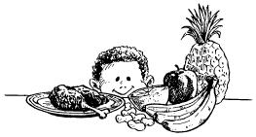
In the kitchen, you and your children can do many things together: put away groceries, prepare meals and snacks, set the table. Every family member can have a job to do! Your children will feel good about their successes as they use their large and small muscles and look for shapes and colors. Be sure the kitchen is a safe place. Keep sharp objects out of reach. Remind your children about family rules in the kitchen.
Help your children become aware of differences in foods.
- Talk with your children about the size, taste texture, and color of foods. Help them to recognize the differences between rough and smooth surfaces, salty or sweet tastes, and the odors of certain foods.
- Ask them to talk about changes in foods as you cook them ("How did it look when it was raw?... when we started to cook it?... how does it look now?"). Help your children to compare the before and after.
- Talk with your children about any foods that have special meaning to your family.
Look for shapes or colors around the kitchen in and on the cabinets, refrigerator and stove.
- Ask your children to find circles, triangles, or squares.
- Play the game, "I see something you don't see and the color (or the shape) IS... " Your children can name the items or foods that are in the kitchen and that fit the description until they get to the item you have in mind.
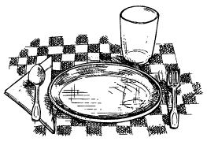
Set the table with your children.
- Ask your children to make sure there is one plate, one glass, and so on, for each person.
- Talk about how to handle the dishes and silverware, so they stay clean and unbroken.
Involve your children in meal preparation.
- All family members preparing food need to wash their hands before handling food.
- Measure with cups, tablespoons, and teaspoons. Ask your children to guess how many tablespoons make a cup of water. Then, help them check it out!
- Let your children pour water with spoons, cups, and pitchers.
- Involve your children in making part of a meal or a snack.
- Talk about opposites big and small, hard and soft.
Sort and name foods after a trip to the grocery store.
- Let your children name each food, or ask them to tell you something about each food, as you take it out of the bag.
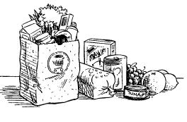
- As you sort the groceries, ask your children to put together all the foods that are the same: fresh vegetables in one place, boxes in another place.
- Talk with your children about the sizes of cans as you put them away—tall and short, wide and narrow.
Name kitchen appliances and their uses.
- Ask your children what the toaster is for, what the oven does. Give safety tips for the use of each appliance, and talk about who can turn them on and off.
- Ask about other ways to toast bread, heat the leftovers. The answers might be very creative!
Let your children help clean up the kitchen.
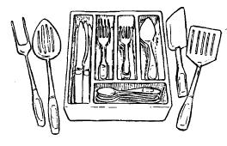
- Ask them to sort eating and cooking utensils by type or use.
- Let them wipe the table after meals. Encourage them to wipe the table from left to right and collect all the crumbs in one corner.

In a Living Room
The living room can be the place for both quiet and noisy activities. Your children will develop their social skills by learning how to be by themselves or how to be a part of the family group. Tell your child which items in the room are on the "Do Not Touch" list. These are activities to build both large and small muscles. The living room is a busy place!
Talk about sounds.
- Ask your children to point to the direction of the sound and describe it.
- Ask you children to tell you about all the things that make loud or soft sounds such as the TV, the radio.
- Sing songs together: old favorites, nursery rhymes. Use a wooden spoon or thick stick as microphone.
Talk about:
- The names of all the furniture in the room, such as the lamp, table, and couch.
- Family stories about the children's grandparents, family histories and when your children were babies.
- The things your children make.
- Your children's favorite TV shows.
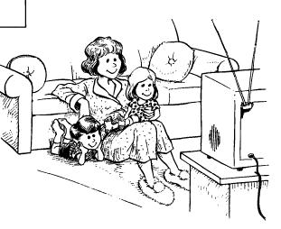
Develop your children's big muscles.
- Encourage your children to help with household jobs: watering plants, sweeping, dusting, vacuuming.
- You and the children can imitate characters from a story or a TV show.
- Act out what these persons do. Help your children to find things around the house for dress-up or to add to the make-believe!
- Turn on music and march around the house. Or, if your family likes to dance, turn on music and have fun!
Read to your children each day.
- Give your children a chance to imitate reading to you from magazines, books, and newspapers. Have a special place for books and magazines.
- Make a "booklet" with your children by helping them cut out magazine pictures and paste them on paper--a "house book" or "animal book." Use other suggestions from your children.
- Ask an older child or other family member to read to a younger child and to you.
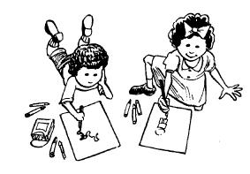
Talk about what it means to be a family member.
- Ask your children to name the members of your family and draw pictures.
- Discuss how members of the family help each other.
- Invite some older family members to tell stories.
- You may wish to write a story about your family or write down stories your children tell you about the family.
Let your children know that they are an important part of the family.
- Give your children a place to store their special treasures.
- Find a place to display your children's "work," such as hanging their artwork on the wall or a door.

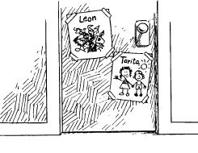
In a Bedroom
The bedroom can be a special place to play alone or to share some special, private time with your child. You and your children can read stories and talk about almost anything! Your children will learn a lot of self-help skills in the bedroom. They will be very proud of their new abilities.
Read to your children daily.
- Tell a story or read a book to your children at bedtime.
- After you've finished reading, ask your children to tell you all they remember about the story.
- Encourage your children to make up and tell stories or repeat a story you have read.
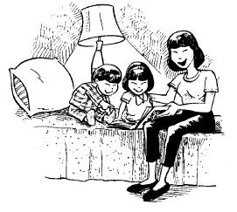
Let your children know that books are special.
- Make a library shelf or book area with your children.
- Use different print materials often: borrowing from the library, making homemade books, and looking at junk mail, greeting cards, newspapers, or magazines.
Talk about clothing.
- Help your children describe pieces of clothing.
- Talk about the front and back, top and bottom of shirts, pants, skirts, dresses.
- Let your children select the clothes they wear for daytime, for sleeping.
- Encourage your children to dress themselves and their dolls or their stuffed animals.
Have special places for storage.
- Help children put toys away by shape or color, or by use for drawing, for building, for cuddling, for pushing.
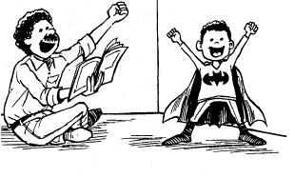
Encourage your children to think, imagine, and be creative.
- Ask questions that have many answers, rather than questions that have right or wrong answers, such as "Where do you think birds sleep? How do you think a rainbow gets in the sky? Where do you think the water goes after it goes down the drain?"
- Ask your children to act out a story you've read to them.
Sort and match clothes.
- Ask your children to sort and stack their laundry by putting all like things together such as underwear in one pile, socks in another.
- Let them sort clothes by "owner" (my shirts, Dad's shirts).
- Ask your children to match a shoe with a shoe, a sock with a sock.
- Give your children a limited choice of what to wear. Ask them why they chose the clothes they did.

In a Bathroom
The bathroom is a great place for children to learn hygiene and practice using their muscles by brushing their teeth and combing their hair. While they're taking a bath, they can learn math and science concepts, such as sinking and floating, full and empty. Safety tip: Always stay with your children when they're in the bathroom! Put red duct tape on all hot water faucets for safety.
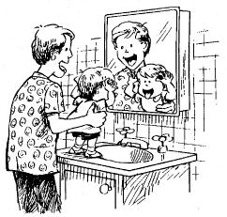
Use mirrors to name body parts.
- Make faces in the mirror with your children—move your tongue, make a kiss, wiggle your nose.
- Talk with your children about all of the things they can do with their eyes—blink, stare, wink.
Look for ways to use different senses in the bathroom.
- Feel and talk about different textures-- soft cotton, hard soap, smooth wall, slippery sink.
- Smell different things—toothpaste, soap.
Let your children play with different things while taking a bath.
- Help your children collect and save things to play with in the bathtub, such as plastic containers, sponges, cartons, and corks.
- Help your children notice which things sink and float.
Practice helping skills with your children.
- Encourage your children to wash their hands and face, brush their teeth, and comb their hair.
- Talk about health and hygiene such as why we wash our hands and face, brush our teeth.
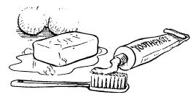
Practice health and safety habits in the bathroom with your children.
- Let your children practice pouring, washing, wiping up.
- Talk about do's and dont's such as turning on the cold water first. Tell them what they can touch in the bathroom.
- Let your children make "warm" water: turning on the cold water first and adding very little hot to prevent burns.
Talk with your children about how it feels to "grow."
- Hang a growth chart on a door and keep track of their height and weight. Show them how they are growing.
- Ask them what they can do now that they couldn't do when they were younger and smaller.
Talk with your children about opposites in the bathtub.
- Encourage them to pour water into and out of containers, making them full, making them empty.
- Discover things that are hard and soft, warm and cold, wet and dry.

In the Surprise Drawer
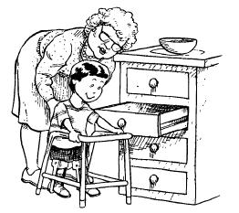
Every family probably has a surprise drawer—the one drawer where all the odds and ends are put. When the surprise drawer is for children, it should be in a safe and accessible location, such as a bottom drawer. This drawer (or a surprise box) can be a treasure chest! It can be a special treat for a rainy day. Make sure all the items are safe before you give them to your children.
Explore the surprise drawer.
- Ask your children to put all the like things together, such as corks or rubber bands.
- Ask your children about the uses of the items in the drawers.
- Your children can draw around some of the items to make pictures with the shapes.
Play guessing games with things from the surprise drawer.
- Hide things in your hands ("What do you think I'm holding in my right hand?").
- Let your children guess amounts ("Will all these corks fit in the cup, or will we need the large bowl?").
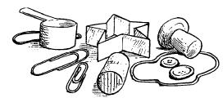
Talk about the contents.
- Help your children name all the items in the surprise drawer.
- Talk about the sizes, shapes, and colors of the items.
- Ask your children about the "feel" of the items—rough or smooth, slippery or sticky, hard or soft.
Create a surprise. Is there anything your children can make from any items in the drawer?
- What about making a collage picture or sculpture with some of the leftover items?
- Let your children surprise you with their own creations.
- Make a mobile by hanging some items from a coat hanger. Place the mobile outside on a tree limb.
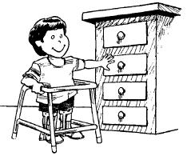
Remember pick-up time!
- Using margarine tubs or other small containers, ask your children to clean out, sort, and put back the contents of the drawer.
If your children are preschoolers, let them add to the collections from "junk" you don't want anymore.
- Corks
- Coffee scoops
- Plastic bottle caps
- Twine
- Ribbon
- Pads of paper
- Buttons
- Greeting cards
- Straws
- Markers
- Tapes
- Rubber bands

Outside the Home
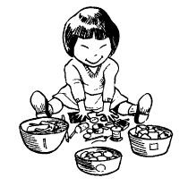
The outdoors! Children should go outdoors every day for exercise, fresh air, and fun. You and your children will have greater freedom outdoors to jump, hop, swing, look, and listen. Let your children make noise! Remind them about any rules you have for playing outside.
Talk about all the things you and your children see in the sky, near the house or apartment
- Colors
- Bright sun
- Moon
- Neighbors
- Cars
- Shapes
- Dark clouds
- Stars
- Snow
- Houses
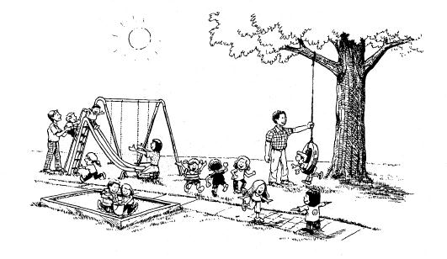
Help your children find animals and insects.
- Tell your children the names of the animals and insects they see and hear.
- Ask your children where they think the animals live, how the insects build their homes, where they get their food.
Help your children dig and plant a garden.
- Talk about each tool you are using and what it does.
- Look at seed packages and vegetables in the grocery store. Then, decide what to plant: radishes, carrots, and other things that grow fast and that you and your child like are best.
- Remind your children to water the growing plants.
Look up toward the sky at different times of the day with your children.
- Talk about the ways that trees bend and what the clouds look like.
- Look for changes over time—how are the leaves different in the fall from the spring? Are there more or less birds in the sky now than there were last month?
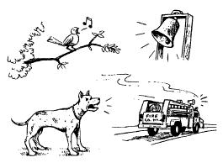
Listen for sounds outside.
- Ask your children to talk about the sounds they hear and where they might be coming from.
- Ask them to name sounds that are the same as inside sounds, different from inside sounds.
Encourage your children to describe all the things they feel or experience.
- Rough trees
- Blowing wind
- Slippery mud
- Smooth stones
- Warm air
- Cold rain

Exploring Your Community
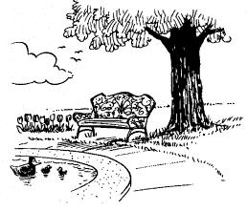
There are many fun places to go in your community. Before you take a trip, talk with your children about what you will see and do. Name the things and people you will look for, such as flowers, animals, fire fighters, or bus riders in the place you are visiting. Talk with your children about your safety rules so that the trip will be pleasant and safe, such as "I want you to hold my hand."
To a park
- Point out special things in the park: a family having a picnic, the gardens, the pathways.
- While walking around the park, ask your children to walk fast, walk slow, or run safely.
- Play games with your children (that have no "losers").
To the library
- Get your own library card to borrow books.
- Ask your children to select three or four books, records or tapes to check out and take home.
- Remind your children about being quiet at the library.
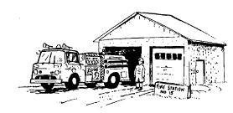
To the fire station
- Call ahead about coming for a visit.
- Talk about fire safety rules for your home and what your children would do if there was a fire.
- Try on different pieces of the fire fighter's uniform. Ask your children what they think each article of clothing is for, what they think the equipment does.
To the train and/or bus station
- Talk about where the bus or train might be going.
- Make up a story about where you would go on the bus or train. What would you do when you got there?
- Ask your children to tell you what they would do while on the bus or train.
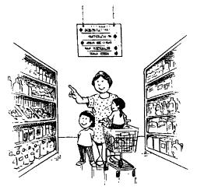
To the grocery store
- Discuss each food item as you put it in the cart: its size, shape, color, and texture.
- Ask your children to name their favorite foods and then name one of yours.
- To keep your children occupied in line, ask questions that have no right or wrong answers, such as: Let's pretend we are having a supper party and you get to choose the menu. "What would you like to serve?"
To the laundromat
- While waiting for the laundry, keep your children occupied by asking questions that encourage creative thinking.
- Ask them to describe how the clothes get clean when you wash them.
- Ask how you could wash the clothes if you didn't have a washing machine.
To a festival and other community event
- Check the listings in the newspaper for local events or listen to the radio for announcements.
- Talk about the event before you go.
- Try a special new snack as a treat.
- Ask your children to name the two best parts of the event.
On a scavenger hunt
- Decide with your children what you'll look for on the hunt.
- Use paper bags for collections.
- Talk about what is safe to touch and what is not.
- Make up a story about the items you collected.
Things You Can Do After the Trip
- Talk with your children about what you saw, heard, touched, or smelled.
- Make a booklet about the trip with your children. Have them tell you a story about the trip as you write it down.
- If you take pictures during the trip, put them in a booklet you make or in a photo album.
- Ask your children to add pictures to a "trip book." Let them cut pictures from magazines of things they saw on their trip.
- Make a collage with your children. Use things found during your walk—moss, stones, leaves.
- Get books from the library about where you went.

Things to Think About
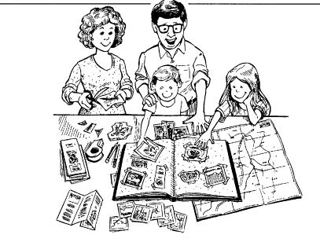
Were the activities you selected fun for you and your family? As you do the activities, they will encourage and help children to learn. They should be fun and offer opportunities for your family to spend meaningful time together. As you remember these activities and plan for the future with your children, it might help you to think about the following:
- Did your children enjoy the activity?
- Which activity did your children enjoy the most? The least?
- Which child enjoyed which activity? Why do you think that's so?
- Which activity seemed too hard? How could you make it easier so that your children can succeed?
- Which activity seemed to be too easy? How could you make it harder so that your children have a challenge?
- Which activity was "just right?" When can you do it again?
- How can you stretch your children's imaginations when you do this or a similar activity?
- What did you learn about your children?
- Ask your children to respond to "What...If" questions related to the activity, such as "What would you have to eat if you lived on the moon?" Or, "What would you do if you worked in this place?"
- What activity can you plan to give your child time to play quietly by himself or herself? Will it help to develop his or her creativity?
- How did you praise your children for trying a new activity and for their positive behaviors? What other ways can you use to encourage them?
- What other ideas do you have? What ideas can your children suggest?
Illustrations Copyright © 1992 by Joseph Azar
https://eclkc.ohs.acf.hhs.gov/parenting/article/fun-learning-parents-children-activities-handbook

